Hide/Unhide Help-Construction objects (HilfsKonstruktion):
Hides / unhides Help Construction objects i.e.: HK Detail- and ModelLines ,
HK TextNotes, HK Dimensions. Latter are identified by letters „HK“ in their FamilyTypeName.
pdfOut_Sheets:
exports multiple Drawing Sheets to pdfs, with papersizeformat matching each sheet format. Filename gets created from sheet parameters. Sheets can be selected either in the Project Browser before running the command or from Sheet-Selection-dialog, popping up when run.
pdfOut_SheetSet:
Same functionality as pdfOut_Sheets, only that sheets contained in a ViewSheetSet get exported.
Create SheetSet fr. Selection:
This tool creates a user named View/SheetSet object in Revit Database containing selected sheets. Selection is made either from Project Browser or Sheet-Selection-dialog.
dwg/dxf Export:
fast dwg/dxf-file export of multiple sheets. Filename specified from sheet parameters. Same functionality as pdfOut_sheets, but as dwg-files.
Sheets from Excel:
fast creation of sheet objects in Revit Database from Excel-table.
Layout Border- and Sheet-Header type are identified by name and are created. Values for parameters Sheet Name, Sheet Nr, Drawn by and Sheet Issue Date of each sheet object can be set.
Prj-Info from Excel:
not implemented yet
Levels from Excel:
not implemented yet

PyRevit:
PyRevit is an Addin for Autodesk Revit which makes IronPython scripts available for accessing the Revit API. It was created and is maintained by Ehsan Iran-Nejad. On his github page https://eirannejad.github.io/pyRevit he defines pyrevit as:
„pyRevit is an IronPython script library for Revit. However, it is not really written as an example library. It is a working set of tools fully written in IronPython that explores the power of scripting for Revit and also adds some cool functionality.“ [https://eirannejad.github.io/pyRevit/whatspyrevit]
Further information can be found his webpage, see the provided links.

In depth look at the pdf_Sheet_Export tool:

Motivation:
Revits pdf exporting function is very limited. There are 2 ways, SheetViews can be exported:
1. For each Sheet the user wants to export he has to manually choose a PaperSize-Format specified in the SheetSetting-Dialog. After hitting the print button the sheet gets exported. User defined filenaming from sheet parameters is not supported. As a default filename the projectname is provided. Exported pdfs have to be renamed manually in the file explorer.
2.
Other CAD programs pdf
This is unconvenient.
There are a lot of addin tools on the appshop which provide functionality, they are all missing the right papersize
Dynamo Solution, Print pdf Node by Konrad Salomon, archilab.net package. On his Blog he describes , First thing users in Dynamo want is pdf export functionality.
Allplan has this tools, User Wish in Revit Ideas

pdfOut_sheets tool:
The pdfOut_sheets tool exports:
- multiple Revit Sheets to pdf at the same time,
- with filenames specified by sheet parameters for each sheet, i.e.
„SheetNumber_Revision_SheetName_Date“
(ex: “A01_b_Floorplan L00_17.06.18.pdf“ ).
- with papersize format automatically matching the sheetsize format
- Sheet selection is made either by selecting Sheets in Project Browser before the script is run or by Sheet-Selection-Dialog.

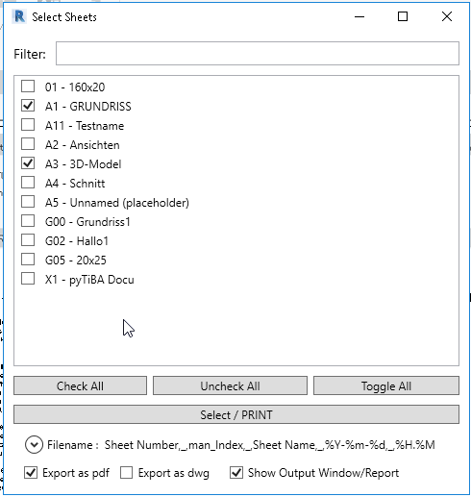
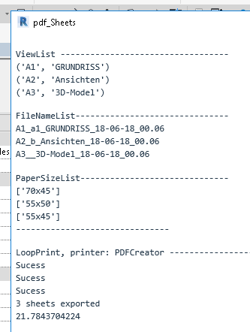

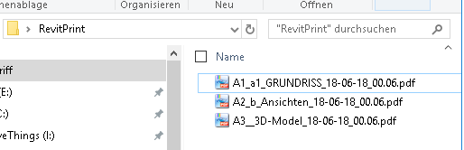

Rough outlines on how the script works
Sheet Selection:
Sheet Selection can be made either by selecting

- The sheet Selection Sheet objects are saved in list: viewlist.
- Getting the Filenames with filename Function:
The filename function iterates over the viewlist. For each sheetview sheetparameters objects are collected and their values extracted. They are turned into strings and concatenated in user specified way. The concatenated string is saved in a filenamestring and appended to a list named filenamelist. It gets returned by the filename-function.
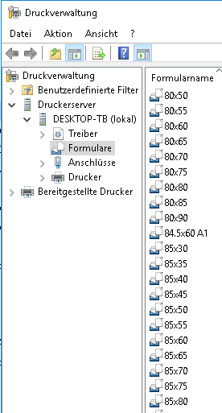
- Matchpapersize function: In order to provide the right papersize one firstl needs the sheet sizes. They can be retrieved from the title block family. The parameters are sheet width and sheet height. They are read only (greyed out in the properties panel)
Secondly one needs the papersize-formats. In the Revit API there exists a
- Print function: takes 1 view and 1 filename , 1 papersize object.

